Chapter 13, Problem 57.

For the ideal transformer circuit of Fig. 13.121 below, find:

(a) I₁ and I₂,

(b) V₁, V₂, and V_{o},

(c) the complex power supplied by the source.

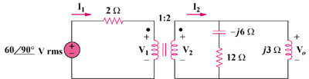

Figure 13.121
For Prob. 13.57.

